**User Manual of Admin Page where Admin can add new user**

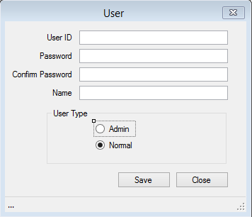

* **This is the Admin page where Admin can add new user by entering user ID, Password, Name and User Type.**